Algorithm Analysis Documentation
Birthday Cake Candles
Brute Force · Decrease & Conquer · Divide & Conquer

Algorithm 1 — Brute Force (Iterative)

Pseudocode
ALGORITHM BirthdayCakeCandles(Candles[n], n) {
counter ← 0 → (1)
max ← -1 → (1)
For i ← 0 to n-1 do → (n+1)
If max < Candles[i] Then → (n)
max ← Candles[i] → (n)
For i ← 0 to n-1 do → (n+1)
If max == Candles[i] Then → (n)
counter ← counter + 1 → (n)
Return counter → (1)
}

Calculation of T(n)
T(n) = 1 + 1 + (n+1) + n + n + (n+1) + n + n + 1

Constants : 1 + 1 + 1 + 1 + 1 = 5
n-terms : n + n + n + n + n + n = 6n

T(n) = 6n + 5

Time Complexity | O(n) — Linear

Algorithm 2 — Decrease & Conquer (Recursive)

Pseudocode
ALGORITHM BirthdayCakeCandles(candles, n, index, maxH, count) {
If index == n Then → (1)
Return count → (1)
If candles[index] > maxH Then → (1)
maxH ← candles[index] → (1)
count ← 1 → (1)
Else If candles[index] == maxH Then → (1)
count ← count + 1 → (1)
Return BirthdayCakeCandles(candles, n, index+1,
maxH, count) → T(n-1)
}

Complexity Analysis — 3 Methods
The recurrence relation for this algorithm is: T(n) = T(n-1) + c

Method 1 – Iterative  T(n) = T(n-1) + c  = T(n-2) + 2c  = T(n-3) + 3c  ...  = T(n-k) + kc  Set k = n-1 :  T(n) = T(1) + (n-1)c  = c·n  ∴ T(n) = O(n) | Method 2 – Master Theorem  T(n) = aT(n/b) + f(n)  a=1, b=1, f(n)=c  NOT directly applicable  because b=1 (not > 1).  Use substitution or  Akra-Bazzi instead.  Result from substitution:  ∴ T(n) = O(n) | Method 3 – Recursion Tree  Level 0: c  Level 1: c  Level 2: c  ...  Level n-1: c  Total levels = n  Cost/level = c  Total = n × c  ∴ T(n) = O(n)

Time Complexity | O(n) — Linear

Algorithm 3 — Divide & Conquer (Recursive)

Pseudocode
ALGORITHM BirthdayCakeCandles(candles, low, high,*maxH) {
If low == high Then → (1)
maxH ← candles[low] → (1)
Return 1 → (1)
mid ← (low + high) / 2 → (1)
left_count ← BirthdayCakeCandles(candles, low, mid,
left_max) → T(n/2)
right_count ← BirthdayCakeCandles(candles, mid+1, high,
right_max) → T(n/2)
If left_max > right_max Then → (1)
maxH ← left_max → (1)
Return left_count → (1)
Else If right_max > left_max Then → (1)
maxH ← right_max
Return right_count → (1)
Else → (1)
maxH ← left_max → (1)
Return left_count + right_count → (1)
}

Complexity Analysis — 3 Methods
The recurrence relation for this algorithm is: T(n) = 2T(n/2) + c

Method 1 – Iterative  T(n) = 2T(n/2) + c  = 2[2T(n/4)+c]+c  = 4T(n/4) + 2c + c  = 4T(n/4) + 3c  ...  = 2^{k}·T($\frac{n}{2^{k}}$) + (2^{k}-1).c  Set $\frac{n}{2^{k}}$ = 1 → 2^{k} = n → k = log₂n :  T(n) = n·T(1) + (n-1).c  = n + nc - c  ∴ T(n) = O(n) | Method 2 – Master Theorem  T(n) = aT(n/b) + f(n)  a=2, b=2, f(n)=c=O(1)  n^{log_b a}  = n^{log₂ 2}  = n^1 = n  f(n)=O(1) = O(n^0)  n^1 > n^0  → Case 1 of Master Thm.  ∴ T(n) = Θ(n) = O(n) | Method 3 – Recursion Tree  Level 0: c (1 node)  Level 1: c+c (2 nodes)  Level 2: c×4 (4 nodes)  ...  Level k: c×2^k  Height = log₂n  Leaves = n  Total = c × 2^0 + c × 2^1  + ... + c × 2^log₂n  = c(2n-1) ≈ 2cn  ∴ T(n) = O(n)

Time Complexity | O(n) — Linear (Master Theorem – Case 1)

Algorithms Comparison

All three algorithms share the same asymptotic complexity across all cases:
Best Case = Average Case = Worst Case = O(n)

Comparison Criteria | Brute Force  (Iterative) | Decrease & Conquer  (Recursive) | Divide & Conquer  (Recursive)
Time Analysis | T(n) = 6n + 5 | T(n) = T(n-1) + c | T(n) = 2T(n/2) + c
Time Complexity | O(n) | O(n) | O(n)
Space Complexity | O(1) | O(n) | O(log n)
Performance | Fastest | Slowest | Average
Implementation | Loops | Function calls  & Base case | Function calls  & Base case
Robustness (Stability) | Stable (Safe) | Unstable  (High Risk) | Average  (Safe for typical n)
Execution Type | Serial | Serial | Parallel
Stack Usage | None | O(n) stack frames | O(log n) stack frames

Conclusion

Although all three algorithms run in O(n) time, they differ significantly in space usage and implementation complexity:

• Brute Force (Iterative): Best practical choice — O(1) space, no recursion overhead, cache-friendly, stable.
• Decrease & Conquer: Elegant but uses O(n) stack space; risky for very large inputs (stack overflow).
• Divide & Conquer: Uses only O(log n) stack space — safer than D&C recursion — and naturally parallelizable, though adds code complexity.

EXAMPLES:
Input:
4
3 2 1 3
Output:
2
1: Brute-Force
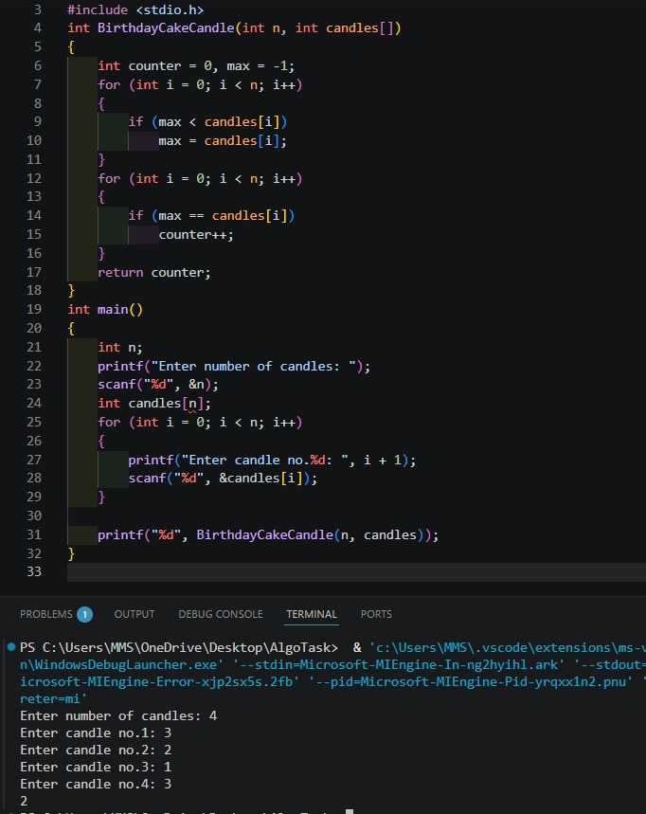
2: Decrease and Conquer
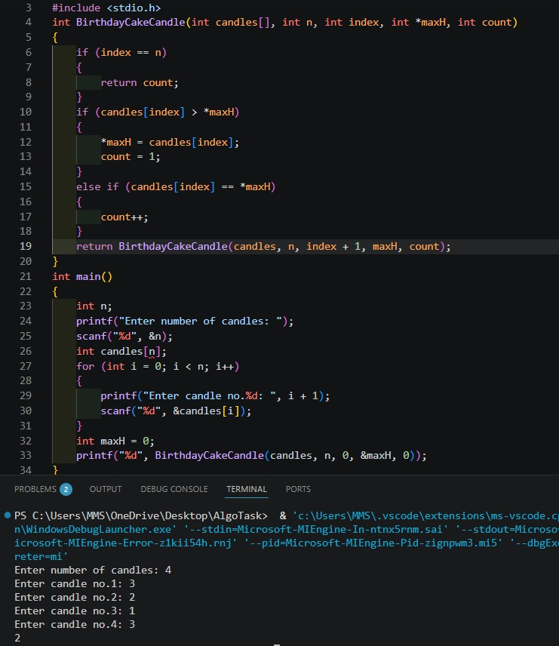

3: Divide & Conquer
